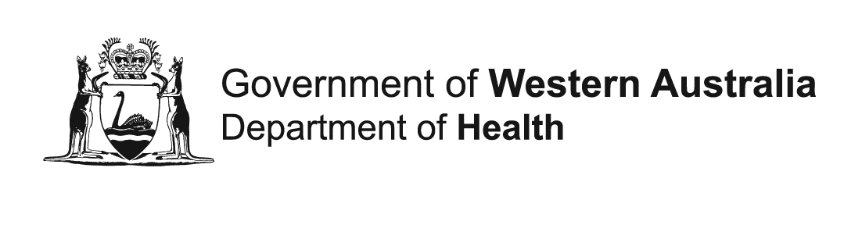
For Office Use Only
CS#
Version | V.1
Date

Extraction:
Family Connections

The WA Family Connections System contains links between individuals who are related, either biologically or legally. The links are created using information recorded on original Birth Registrations and Midwives’ Notifications. No information is known about adoptions, including step, local or overseas adoptions.

Please note: Currently, the genealogy is primarily limited to parents and siblings of people born in WA since 1945. However, extended family members (including grandparents and other second-degree relatives) have been identified in many cases.

Genealogical data received from this application may differ from actual data collected from families via questionnaires or other methods. Family structures may include individuals who have been adopted (in or out), step-relatives, or recent deaths. It is important that any such discrepancies should be treated with respect and sensitivity. If, through fieldwork, you learn that a subject has been adopted, you will not be able to obtain additional linked data for that individual’s biological relatives.

Scope of relationships
Family connections may be specified as “within” a cohort group, or “within and outside” a cohort group.
- Requests for relationships “within” a cohort group will be provided via a mapping file indicating which members of the group are related to one another.
- Requests for relationships “within and outside” a cohort group will be provided with a separate data extract and associated mapping file for all relatives of the group members, irrespective of whether those relatives are part of the cohort group themselves.

Relatives of cohort group
Cohort Group
Cohort Group
Relatives of cohort group

WITHIN COHORT GROUP ONLY WITHIN AND OUTSIDE COHORT GROUP

Please note: Cross-over can occur when a cohort member appears in more than one group of interest. For example, a mother identified in one cohort could be the child identified in another cohort. Any cross-over should be noted in the Methodology section of the Application for Data form, acknowledging the likelihood of cross-over when these cohort members are analysed.
- FAMILY RELATIONSHIPS
1.1 Please complete one row in this table for each distinct family group (add or remove rows as required). If the specifications for a group are variable, please split it into separate sub-groups, each with distinct specifications.
Family group name | Source group | Scope of Relationship | Relationship types
e.g. Siblings of cases | e.g. Cases | Within the cohort group only  Within and outside of the cohort group | Mothers  Fathers/other parent  Children  Grandmothers  Grandfathers  Grandchildren | Full siblings  Half siblings  Aunts  Uncles  Cousins
 |  | Within the cohort group only  Within and outside of the cohort group | Mothers  Fathers/other parent  Children  Grandmothers  Grandfathers  Grandchildren | Full siblings  Half siblings  Aunts  Uncles  Cousins
 |  | Within the cohort group only  Within and outside of the cohort group | Mothers  Fathers/other parent  Children  Grandmothers  Grandfathers  Grandchildren | Full siblings  Half siblings  Aunts  Uncles  Cousins

- SERVICE DATA EXTRACTION
2.1 Is the time period for the service data extraction for any of the family groups to be based on an index event? | NO  YES → Provide definitions of index events and family groups they apply to:
e.g. Siblings of cases - date of first cancer diagnosis (WA Cancer Registry)
2.2 If you are requesting multiple family groups, do they all have identical data extraction criteria? | N/A – requesting one family group only  Yes → Complete 2.3 once for all groups and write ‘All’ in the ‘Family Group Name’ column  No → Complete 2.3, providing separate extraction details for each family group

2.3 Please specify the datasets you require, the time period and any restrictions on which records you need. Insert rows in the table as required.

Please note this section only needs to be completed where family connections are being requested within and outside the source cohort group. For family connections within the cohort group only, leave this section blank, as their extraction criteria have already been provided in the applicable Extraction form.
Attach variable lists (Module 3) (download from https://www.datalinkage-wa.org.au/resources/application-forms/)

Where requesting Midwives Notification System, Birth Registrations & WA Register of Developmental Anomalies:
Please specify below whether you need where the individual is the baby, records where they are the parent or both.

Family group name | Dataset | Time period | Extraction Criteria/ Restrictions
e.g. Siblings of cases | e.g. Hospital Morbidity Data Collection | e.g. Jan 1995 – most recent | e.g. All linked records from 5 years before and 1 year after index event, which meet all of the following criteria:  - participant is 18 years or over at time of record  - principal diagnosis code for conditions of interest (ICD codes provided)
2.4 Please specify any restrictions on WA Cancer Registry data if applicable:
WA Cancer Registry:
Please specify the record scope from the following options:
Malignant and invasive cancers only
Malignant and invasive, benign, in-situ, and uncertain cancers only (excluding squamous cell and basal cell carcinomas of the skin)
All cancers including invasive malignancies, benign, in-situ, uncertain, and squamous cell/basal cell carcinomas of the skin.
2.5 If you are requesting multiple family groups, do they all require the same variables? |  |  | N/A – requesting one family group only  Yes  No → Attach a separate variable list for each family group and specify which group it applies to.

